**UML Diagram**

1. **Structural diagrams**

* **Class diagram**

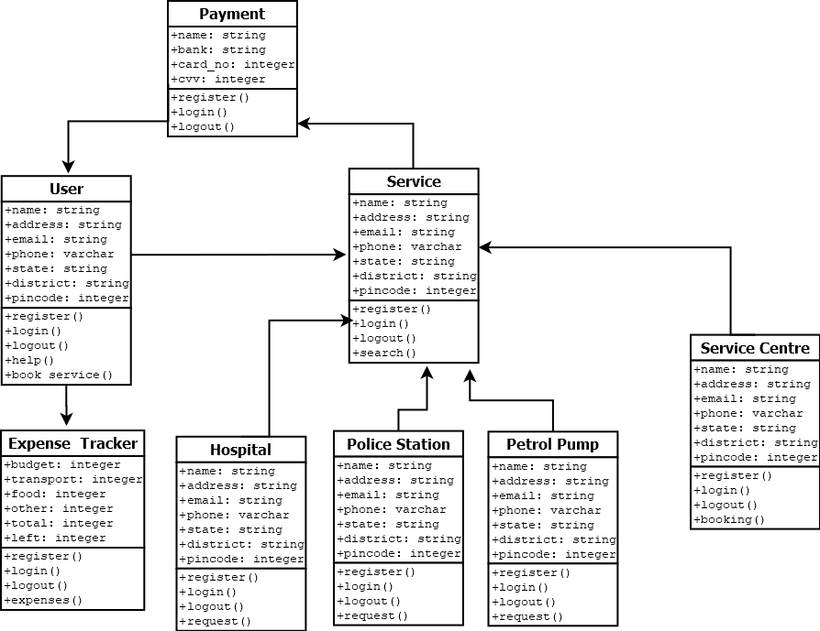

* **Object diagram**

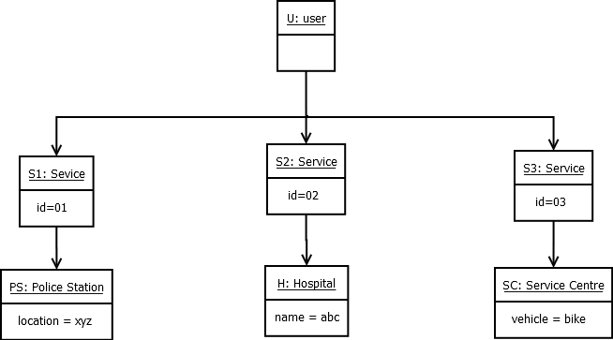

* **Deployment diagram**

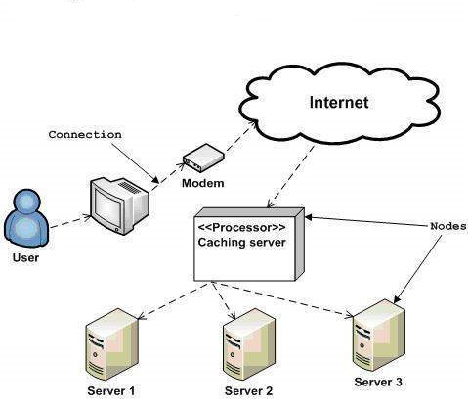

1. **Behavioural diagram**

* **Use case diagram**

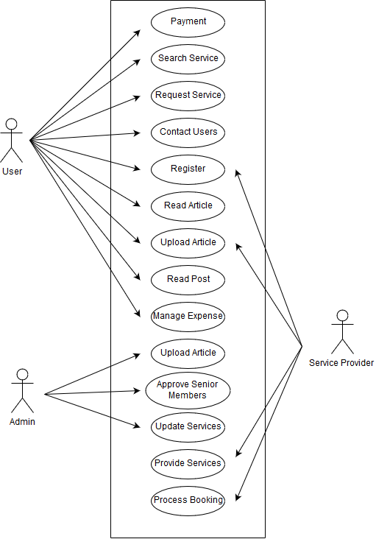

* **Collaboration diagram**

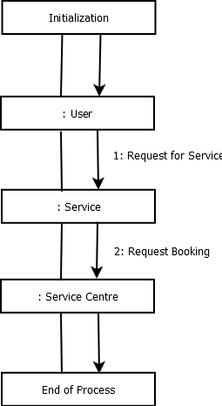

* **Statechart diagram**

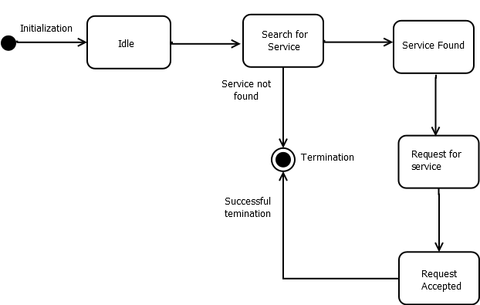

* **Activity diagram**

